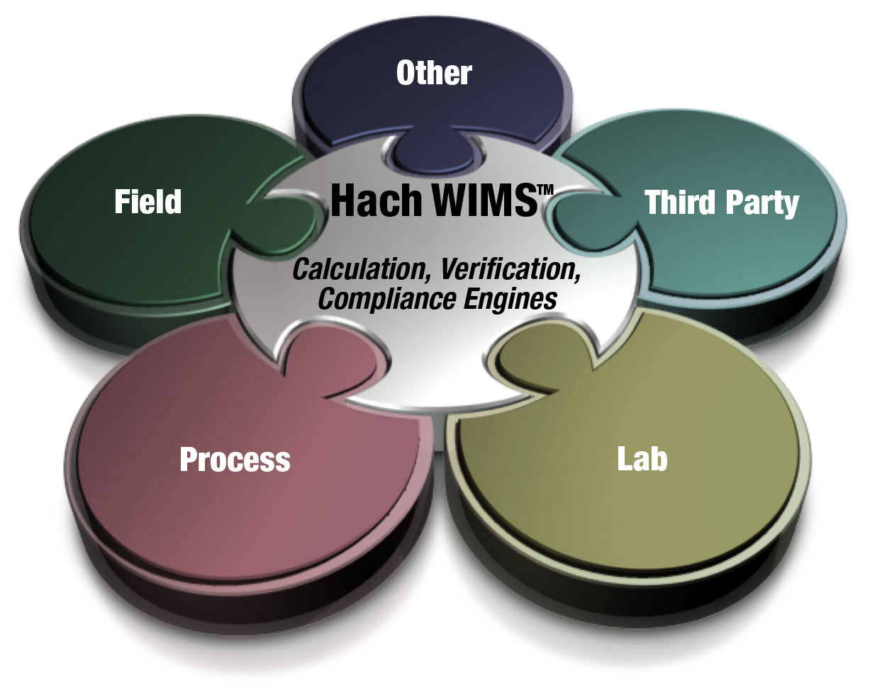

**Administrator’s Guide**

**Hach WIMS­­™ Multi-User**

|  |  |  |
| --- | --- | --- |
| **Version** | **Date** | **Comments** |
| 1.0 | July 15, 2014 | WIMS 7.5 |
|  |  |  |

Table of Contents

1.1 Introduction 3

1.2 Hach WIMS System Requirements 3

1.3 System Overview 4

1.4 Installation Preparation 6

1.5 New Installation 8

1.6 Hach WIMS Server Setup 10

1.6.1 Creating New Hach WIMS Facilities 10

1.6.2 Database Upgrades 11

1.7 Hach WIMS Services 13

1.7.1 INI Files 13

1.7.2 ADOCALC 14

1.7.3 DBAHelper 14

1.7.4 Email Gateway 14

1.7.5 GNR Server 15

1.7.6 Scheduler 15

1.7.7 Watchdog 15

1.8 GNR Server Service Setup 16

1.8.1 GNR Server Service as Administrator 16

1.8.2 GNR Server PDF Printer 16

1.9 Updating the Hach WIMS Client 19

1.10 Hach WIMS User Messages 20

1.11 Backing up a WIMS Facility 20

1.12 Restoring a Hach WIMS Backup 21

Appendix A: Enabling Relaying on your Email Server for Hach WIMS 22

# 1.1 Introduction

The Hach Water Information Management Solution™ Multi-User (referred to as WIMS­­ in this manual) is a data management system specifically designed for water and wastewater facilities. It allows you to track, report, graph, and analyze facility data including SCADA, lab, and operator entered data. The software comes in an on-premise version to be installed at the customer site or as an online, software as a service (SaaS) solution. The Hach WIMS­­TM on-premise system consists of a rich front-end client running on each user’s PC with a backend Microsoft SQL database. This manual will assist the system administrator to install, configure, and maintain the on-premise WIMS system. The online solution only requires a system login.

**Knowledge Base**

Our Knowledge base website provides various articles and information for additional support. To access the knowledge base, please visit. <http://www.opssys.com/instantkb/>. Use browse or search functions to find information for the various components of the Hach WIMS System. Throughout this guide are links to Knowledge Base articles for specific additional information and support.

# 1.2 Hach WIMS­­ System Requirements

**Hach WIMS Client and Components**

**Operating system:**

* Microsoft Vista
* Microsoft Windows Server 2003 Service Pack 1
* Microsoft Windows Server 2003 R2 Service Pack 2
* Microsoft Windows Server 2008
* Microsoft Windows Server 2008 R2
* Microsoft Windows Server 2012
* Microsoft Windows Server 2012 R2
* Microsoft Windows 7
* Microsoft Windows 8, 8.1
* See <http://www.opssys.com/instantkb/Article.aspx?id=12215> for a complete list

**Data access:**

* Microsoft SQL 2012 Express Edition – included on the WIMS DVD.

**Hardware** (Minimum requirement for good performance):

* 1 GHz processor (32 or 64-bit)
* 1 GB System RAM
* 10 GB of available disk space
* Screen resolution of 1024x768 with 32bit color depth
  + - * DVD-ROM

**NOTE:** MSSQL 2012 Express Database, Hach WIMS­­ interfaces, Calc Engine, and GNR Server are designed to run as Windows (NT) services.

**Hach WIMS DATABASE NETWORK BANDWITH SPECS**

Hach WIMS­­ is based upon true client-server architecture. The client software has a large footprint and requires a speedy connection to the database server.

It is difficult to precisely state the minimum network bandwidth requirements for Hach WIMS­­. It was developed to work efficiently on a 10 Megabit network. Depending on your current network bandwidth utilization, even 10 Megabit may not be enough.

We do not recommend deploying Hach WIMS­­ onto T1 bandwidth rated networks. If you are bound by such network hardware, please consider running the Hach WIMS­­ client on an application server (such as Windows Terminal Server, or Citrix).

# 1.3 System Overview

The Hach WIMS­­ data resides in an MS SQL Express database. The WIMS­­ database stores data from a variety of sources including LIMS, SCADA, and manually entered data. Raw data is calculated as needed and stored in the database.



**Definitions:**

**Client/server:** An architecture in which the user's PC (the client) is the requesting machine and the server is the supplying machine, both of which are connected via a local area network (LAN) or wide area network (WAN). In this environment, servers are used to store and share data with the client PCs. The server part of the client-server architecture will be a large-capacity computer with a large amount of data and functionality stored on it. The client portions of the client-server architecture are smaller computers that are used to perform computer-based responsibilities.

**Client software:** The Hach WIMS­­ executable (Hach_WIMS_Client­­.exe) thatresides in a user's computer and is used to interact with the database. The client processes the user interface and performs some or all of the application processing.

**Concurrent Users:** Multiple users may log into the WIMS system at the same time. These users are concurrent users because they are accessing the system concurrently.

**Named Users:** A unique name for each user that will use Hach WIMS Online. The online solution does not support concurrent users.

**Facility Database:** Any physical site and its subcomponents (including lift stations, wells, collection sites, sample sites, etc) that require a separate database (hosted locally or remotely as part of an enterprise system). Security is administered on a per database basis.

**Facility Database Size:** The amount of space available to store data

**Variables:** Parameters, data tags or calculations to be tracked (influent flow, raw PH, etc.)

**Server software**: Resides in a server and provides services to multiple users on the network. A database server maintains the databases and processes requests from the client to extract data from or to update the database. An application server provides additional business processing for the clients.

**Windows Services:** Applications that run in the background, that do not require login or have no user interface. Typically these are run on the server. Also known as NT Services.

**MSSQL 2012 Express:** A 10GB relational database. A version of the Microsoft SQL Server database platform intended for users that don’t have very large data needs.

**MS SQL Server:** A relational database management system (RDBMS) from Microsoft that is for large data requirements with many concurrent users

**Oracle:** The Oracle Database (commonly referred to as Oracle RDBMS or simply as Oracle) is a relational database management system (RDBMS) produced and marketed by Oracle Corporation and typically used in large enterprise applications

**SMTP Server: U**sed to send email. (Simple Mail Transfer Protocol)

**Server\computer name:** The unique ID of a computer on a network. The computer name can be found in System Properties on the Computer Name tab.

# 1.4 Installation Preparation

Hach WIMS­­ Multi-User is designed run on a single PC or a multi-user network. Below is a description of the system architecture.

1. Single-PC Architecture – The entire application has to be on a Windows based machine (e.g. XP, 2000, 2003, Vista, 7, 2008 or higher )
   1. Server & client software are installed on same machine
   2. Server software consists of the MSSQL 2012 Express DATABASE ENGINE, ADOCALC Service, DBA Helper, and Email Gateway.
   3. The Client software is the Hach WIMS­­ executable which connects to the DATABASE engine
2. Multi-User Architecture – The *Server software* has to be installed once on a Windows NT based machine (e.g. NT 4 SP6, XP, 2000, 2003, Vista or higher)
   1. Determine which computer in your network is going to be the server that will house your MSSQL database.
   2. The client software can be is installed on as many PCs as you want so long as that PC is on the same network as the server. The Hach WIMS­­ executable client software connects to the server to get the data.
   3. Server software consists of the MSSQL 2012 Express DATABASE ENGINE, ADOCALC Service, DBA Helper, and Email Gateway.

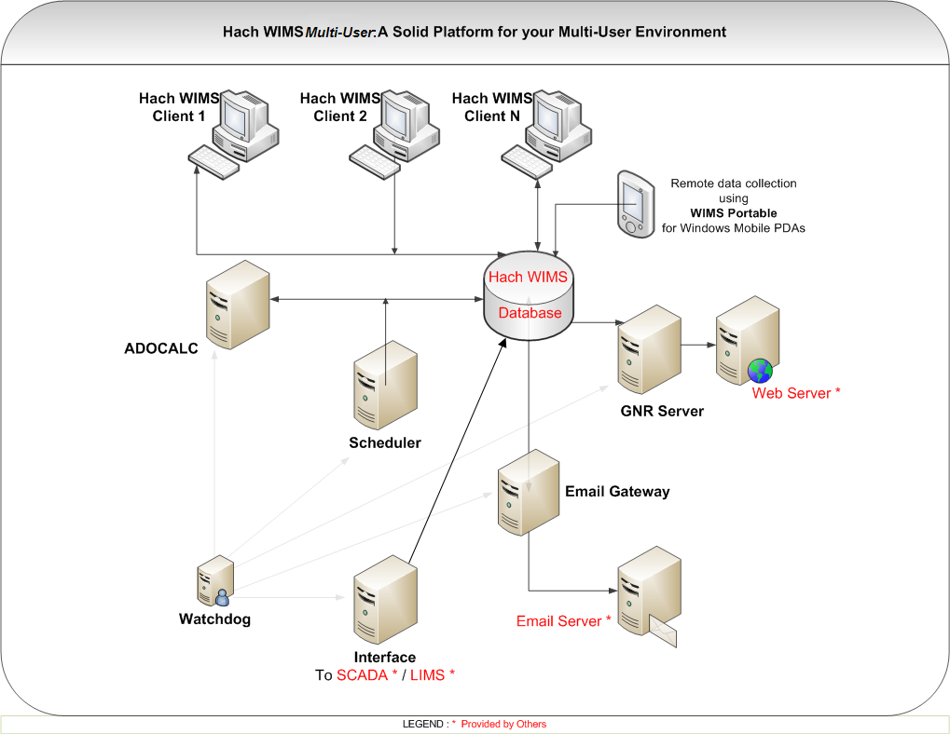

***Which PC should the DBMS be installed on?***

The MS SQL Express DBMS must be installed on a robust server or PC that will always be on.

Hach WIMS by default utilizes the MS SQL 2012 Express DBMS which has a 10GB per database limit. MS SQL 2012 Express cannot be installed on older operating systems such as XP. If the MS SQL Express must be installed on a Windows XP PC, the MS SQL 2005 Express will be installed, which has a 4GB per database limit.

IT IS STRONGLY RECOMMENDED that the DBMS be installed on a Windows 7 SP1, Windows Server 2008 or later OS to take full advantage of the system.

See <http://www.opssys.com/InstantKB/article.aspx?id=14200> for more information on MS SQL Express versions and limits.

Below are some additional definitions of the items and options for Hach WIMS­­:

**Server Setup:** Utility used to create WIMS­­ tables, stored procedures, upload clients, etc…

**ADO CALC:** The WIMS­­ Calc engine is a Windows Service that monitors the WIMS­­ databases and calculates data as required so it is available for reports, graphs, etc… ADO Calc should be placed on a powerful PC that is close to the Server. **NOTE**: ADO Calc can run on the server, which will reduce network traffic and improve system performance.

**DBA Helper**: A Hach WIMS­­ Windows Service that performs backups of the database.

**Email Gateway:** A WIMS Windows Service that connects to your SMTP mail server and relays the emails generated by the Hach WIMS­­ Client (i.e. you choose to output a report or graph to email) or emails generated by the GNR Server (e.g. reports or graphs that are output on a scheduled basis)

**Scheduler:** A WIMS Windows Service used to schedule output of report or graphs, database calculations, or database backups.

**GNR Server:** A WIMS Windows Service that receives requests from the scheduler to output reports and graphs, generates the output, sends the output to a printer, a file, or to email (i.e. it sends it to the email gateway)

**IABroker:** Facilitates the interaction of 3rd party software’s interaction with the WIMS System. (E.g. IFix)

**Watchdog** The Hach WIMS's Watchdog service is a background Windows Service that keeps watch on the connection to the database and will restart the other services in the event of a connection lost.

# 1.5 New Installation

Hach WIMS­­ installation uses the WIMS­­ Platform Installer. This Software assists you while installing the WIMS­­ Software.

**NOTE: If you are upgrading from a previous version (OPS SQL), please refer to Upgrading from 6.x.x section for installation. Please make a backup of your old system!**

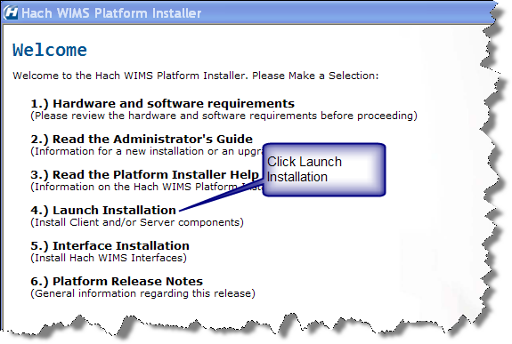

1. Close all programs that are currently running.
2. Place the Hach WIMS­­ DVD into your DVD drive and the Hach WIMS Platform Installer Welcome will be displayed. If the Welcome screen does not appear, double click on d:\Launcher\Launcher.hta where d: is your DVD drive.
3. Click **Launch Installation** option from the Hach WIMS­­ Platform Installer Welcome.

**NOTE:** You may see a Prerequisites Wizard if any of the prerequisites are not installed. Please install these Prerequisites using the Prerequisites Wizard to continue installations. (.Net Framework is a common missing prerequisite.)

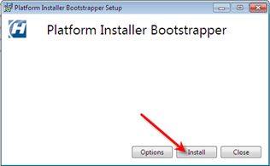

4. Platform Installer Bootstrapper will be displayed. Click .



**Note:** Depending on your OS, you may be prompted to allow the program to make changes to your computer (User Access Control). Click Yes if prompted.

5. The Platform Installer will ask you to review and agree to the License Agreement. Check the Box if you agree and click **Next**.

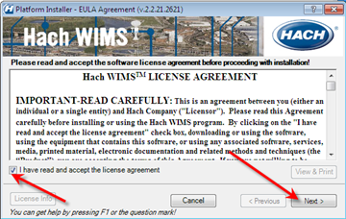

1. The Platform Installer will launch. Enter your Serial number and Browse to your License File (a file with a .License2008 extension, located in the root folder of your WIMS DVD). Click the **Next** button. (Your Serial Number should be on the WIMS DVD Case or it may be emailed to you.)

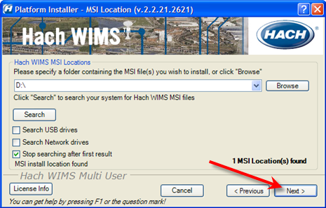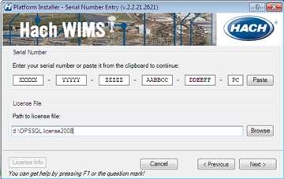

1. The Platform Installer will search for Hach WIMS­­ MSI locations. You may need to browse to the MSI Location using the Browse button. When a location is found, a popup will inform you. Click **Next**. If you are installing from the DVD you can just click **Next**.



1. Install the components and click the **Next** button.

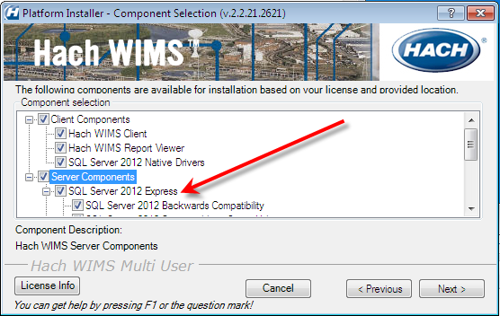

* 1. Server - You only need to install the server components on the **one** machine that the WIMS client software will be communicating with. It is recommended that you install all the server components on the one server machine. It is also recommended that you install all of the client components on that machine.

The install will install SQL Server 2012 Express, this indicates that this PC is compatible with MS SQL 2012 Express. If this line lists SQL Server 2005 Express, it is recommended that a different PC is used for the Server Components.

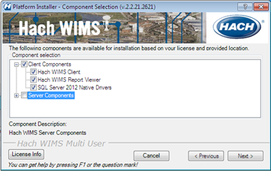

* 1. Client - If you are installing just the client, only the client components are selected and **none** of the server components.

1. Choose your default installation directory and your MS SQL Server Instance that will host your WIMS databases. This directory will be the default and each component will be installed into this directory.

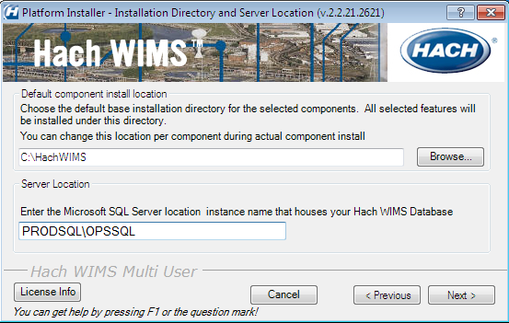

**NOTE:** The MS SQL Server Instance is usually the host computer name\instance name. The WIMS WIMS SQL Server 2012 Express instance is always named “OPSSQL” For example, if the WIMS SQL Server 2012 Express Server Component was installed on the PRODSQL server you would enter PRODSQL\OPSSQL.

If you are installing the SQL Server 2012 Express Server Component during the current install, enter:

LOCALHOST\OPSSQL or (local)\OPSSQL

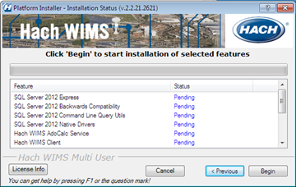

1. The Platform Installer will list the Components that you selected and prepare them to be installed. Click the **Begin** button. Each Component will have its own installation wizard. Complete each wizard. See the Component Installation section for help with each wizard. Press the **finished** button. Hach WIMS­­ is now installed.

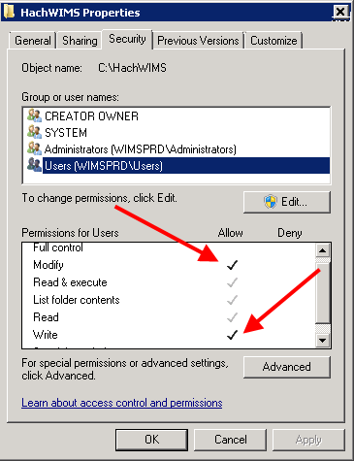

**NOTE:** Depending on your operating system and settings you will need to grant privileges to users so they can use WIMS. WIMS needs users to be able to create/write/modify files in the HACHWIMS folders and subfolders. This most is most commonly done in Windows 2008 R2 and Windows 7.

# 1.6 Hach WIMS­­ Server Setup

The Hach WIMS­­ Server Setup program allows the administrator to create new databases, restore backed up databases, and perform database upgrades.

## 1.6.1 Creating New Hach WIMS­­ Facilities

This process will require you to specify a unique identifier and a facility name for the new facility. The unique identifier is used to create a database under which all tables, stored procedures, and triggers will be held for the new facility.

**Unique Identifier:** This field can only contain letters. No numbers or other special characters. You are limited to a maximum of 8 characters – we recommend you use 4 characters or less.

**Data Source:** The MS SQL Server that will be hosting this database.

**Facility Name:** You should use your common facility name. If you call your plant Rocky Creek WWTP – type in Rocky Creek WWTP.

You will use the server setup utility to create a new Hach WIMS­­ database. This utility will require you to specify a unique identifier, data source, and a facility name for the new facility.

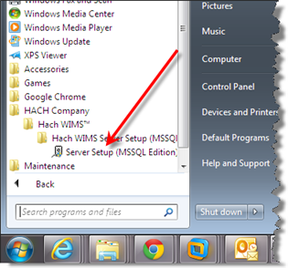

1. Run **Hach WIMS­­ Server Setup**.

1. Click **Next**.

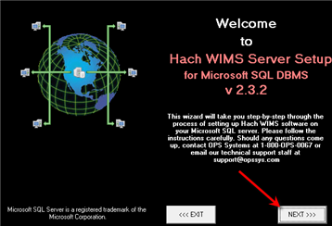

1. Your MSSQL Server Name should already be in place. If it is not, enter it here (Computer Name\Instance – e.g. (local)\OPSSQL). Click **Next**.

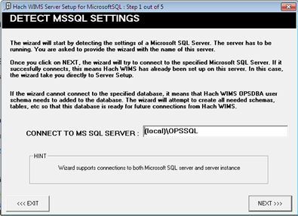

1. Enter a Hach WIMS­­ Username and Password and click **Next**. The system defaults to:

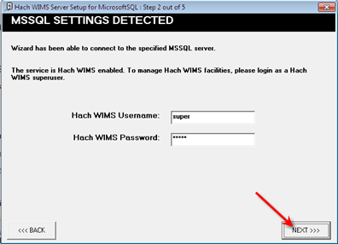

Username: Super

Password: Super

1. Click on the **New Facility Tab** to name your database. You must enter information into the following 2 fields:

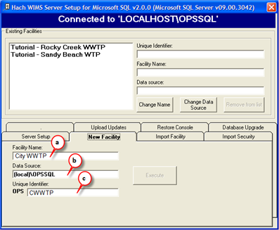

**a. Facility Name:** You should use your common facility name. If you call your plant City WWTP – type in City WWTP.

**b. Data Source:** This should match the server you are connecting to.

**c. Unique Identifier:** A short identifier for the new database. This field can only contain letters. No numbers or other special characters. You are limited to a maximum of 8 characters

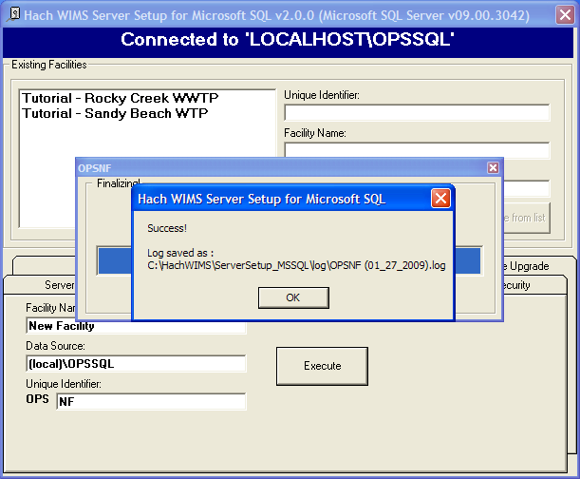

6. Click **Execute**. The Server Setup will create a new database and display the Success message. If you do not get a success, then your facility may not have been created.

7. All new facilities are upgraded to the latest database version during their creation. This means you should be able to login to your new facility immediately.

## 1.6.2 Database Upgrades

The facilities in the Hach WIMS system may not be up to date with the current version of Hach WIMS. You will need to upgrade these facilities using Server Setup before you are allowed to use them.



NOTE: All users must exit WIMS­­ before proceeding.

1. Start **Server Setup**.

1. Click **Next** to Start Server Setup:



1. Input Server/Instance Name. Click **Next**.
2. Input Username and Password and click **Next**. The default Username and Password are:

Username: Super

Password: Super



1. Select the **Database Upgrade** Tab.
2. Click the **Refresh** button for a list of databases that are not up to date.
3. Press the **Database Upgrade** Button to upgrade all the databases in the list.

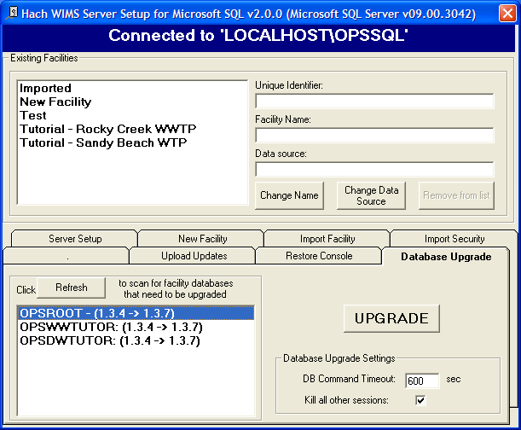

1. The system needs full access to the database. It will terminate the connection for anyone currently logged in. You will need to restart your ADOCALC and GNR services once the upgrade is complete. Click the **Yes** button.

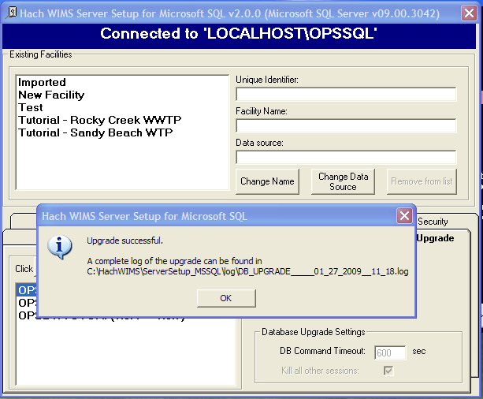

1. Upon Success you will be able to log into any of the upgraded facilities.

# 1.7 Hach WIMS­­ Services

Hach WIMS­­ installs several Windows services. These services perform a variety of tasks that are essential for Hach WIMS to run properly. To view your services and to verify they are running, start “**Services.msc**”.

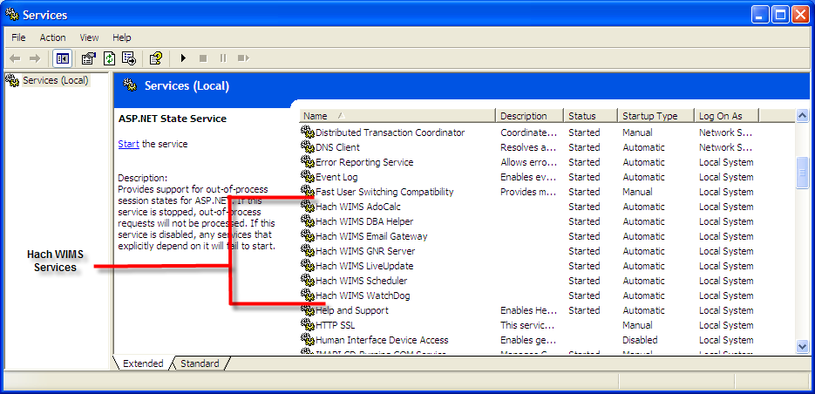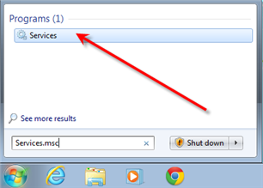

Hach WIMS­­ Services and the MSSQL 2012 service should have a Startup Type of Automatic and the Status should always be started. If you are having problems with a service, you may want to restart it. You can do this from the start menu. You can go to each services folder and find the restart services item.

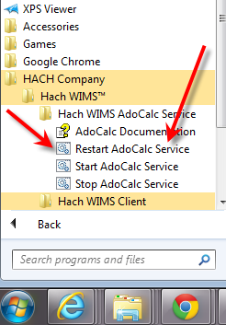

## 

## 1.7.1 INI Files

Services in Hach WIMS­­ use INI files to set up some basic initialization settings. All these INI files share at least 3 fields. Additional fields will be listed under each services section. INI Files are located under each service’s directory in the Hach WIMS­­ root directory. (Default is C:\Hach WIMS­­) INI Settings are formatted as ATTRIBUTE=VALUE. In this section we list attributes and which values are acceptable.

***HACHWIMS_CONNECTION_DBTYPE:***

For standard edition, this should be equal to 2. This Indicates where we are using MSSQL or Oracle.

***HachWIMS_Connection_Provider:***

This signifies the OLEDB provider that ADOCALC should use. SQLNCLI11 is typical.

***HachWIMS_Connection_Datasource:***

This is your Server Name\instance Name of the Hach WIMS­­ database that this service will interact with.

## 1.7.2 ADOCALC

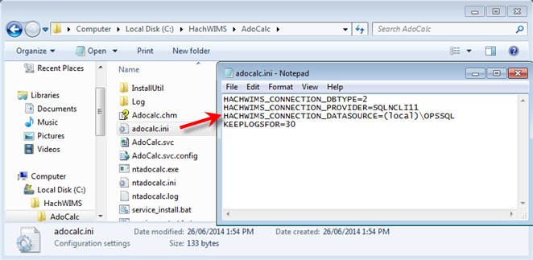

ADOCALC is the Hach WIMS­­ calculation engine. It should be online and connected to your database all the time. When a Hach WIMS Client calculates data, it sends a calculation request to ADOCALC, the ADOCALC service then performs the calculation and notifies the client that the calc is complete. Example ADOCALC.INI:

***KEEPLOGSFOR***

The ADOCALC service creates extensive logs of its activity. These logs are located in the log subfolder (default c:\HachWIMS\adocalc\log). This sets the number of days that the log files are kept.

## 1.7.3 DBAHelper

The Hach WIMS DBAHelper service generates the Hach WIMS­­system back up files. When a back up is requested from inside Hach WIMS­ or by the scheduler service­, the DBAHelper service will perform the backup and places it in a location specified in its INI file.

The INI File has 2 additional fields.

***KEEPLOGSFOR***

The number of days logs will be saved.

***LOCATION***

Specifies the default path of where DBAHelper will place the backup files.

## 1.7.4 Email Gateway

The Hach WIMS­­ Email Gateway service sends emails from Hach WIMS­­ to a specified SMTP to be delivered via Email. For additional Information please consult our Knowledge Base. <http://www.opssys.com/instantkb/Article.aspx?id=12003>.

The INI File has 6 additional fields.

***KEEPLOGSFOR***

The number of days logs will be saved.

***SMTP***

Specifies the SMTP Server.

***SMTPPORT***

Specifies the port that the SMTP is expecting data to be pushed through.

***SMTPAUTH***

This tells the email gate way if the SMTP will require authentication (login and password) 1 = authentication is required. Anything else = authentication is not required.

***SMTPUSER***

The Username for this SMTP Server.

***SMTPPASSWORD***

The Password for this SMTP Server.

## 1.7.5 GNR Server

The Hach WIMS­­ GNR Server service sends scheduled reports and graphs to their scheduled output (email, disk, or a printer). The GNR Service may require additional setup (see below in GNR SETUP section).

The INI File has 2 additional fields.

***KEEPLOGSFOR***

The number of days logs will be saved.

***HACHWIMSCLIENT***

Specifies the path to the Hach WIMS­­ client.

## 1.7.6 Scheduler

The Hach WIMS­­ Scheduler service keeps track of scheduled tasks in the Hach WIMS­­ System. It tracks scheduled database backups, database calculations, scheduled reports, and scheduled graphs.

The INI File has 1 additional field.

***KEEPLOGSFOR***

The number of days logs will be saved.

## 1.7.7 Watchdog

The Hach WIMS­­ Watchdog service assures all the other services are up and running. When one of its specified services stops illegally, the watchdog service will restart it automatically.

The INI File has 5 additional fields.

***KEEPLOGSFOR***

The number of days logs will be saved.

***POLL_EVERY_MS***

Specifies how often watchdog checks in on each service.

***CONNECTION_TIMEOUT_S***

Specifies how long watchdog waits for a service before it’s considered timed out.

***STAY_CONNECTED***

***NTSERVICE***

Specifies the name of an NT Service that watchdog needs to keep track of. This entry can be added multiple times to add any NT Service.

# 1.8 GNR Server Service Setup

GNR may require additional setup depending on how your system is configured. GNR Server needs to be logged in as an administrator on the computer it’s installed on. Set up the printer for the GNR administrator user that GNR will have access to (including a PDF Printer).

## 1.8.1 GNR Server Service as Administrator

Services run under the Local System Account do not have access to printer information. For the GNR Server to interact with your printers, the GNR Service **MUST** be run under an admin account.

1. Open up **Services.msc** (go to start->run)

2. The services.msc window will open up. Search for the Hach WIMS­­ GNR Server Service.

3. Right click the Service and select properties.

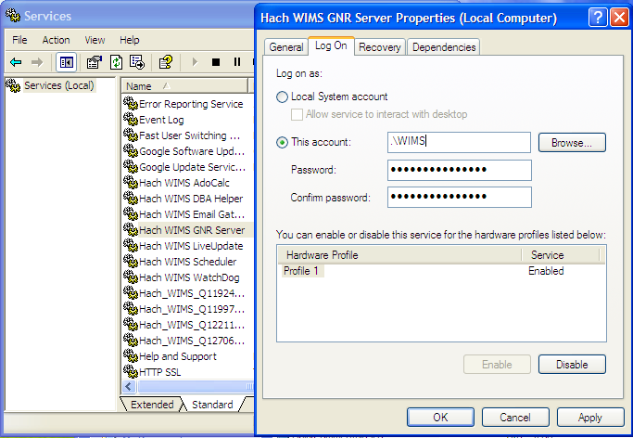

4. Select the **Log On** Tab.

5. Select the “**This Account**” Radio button.

6. Type in a Windows administrator’s account Username and Password

7. Click **OK**. This should change the login information for this service.

## 1.8.2 GNR Server PDF Printer

When you set up GNR to run under an administrator account, GNR has access to printers only added to that account. If you would like to have PDF capabilities, you will need to add a PDF Printer to the GNR User account. Visit <http://www.opssys.com/instantkb/Article.aspx?id=10032> for further instructions and access to files.

1. Login as the Windows User that GNR Server is running under (WIMS in example above)
2. Go to **Start/Settings/Printers And Faxes**
3. Install at least one printer driver. This driver can be a "dummy driver" and does not need to have printer hardware behind it. In case you want the GNR Server to print to multiple print locations, set up all drivers needed.

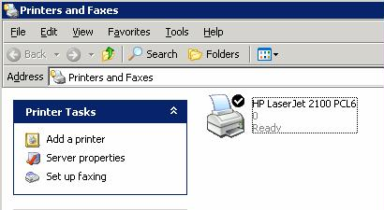

1. Run **pdf995_v12.exe** (Downloaded from Knowledge base article, <http://www.opssys.com/instantkb/article.aspx?id=12741> ). Choose a path where you want to extract the installation files.

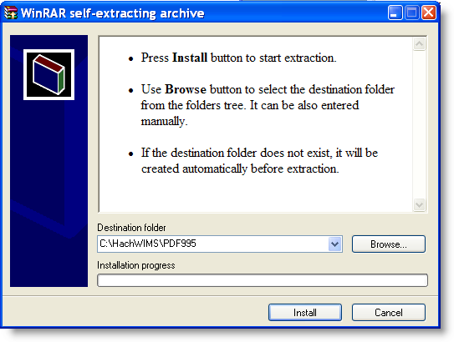

1. Click **Install**. The files will be extracted and the program will close.
2. In explorer, navigate to the directory where you just extracted the installation files.

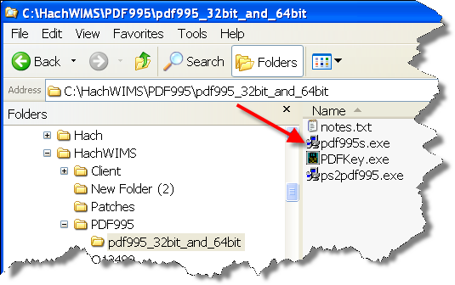

1. Run **pdf995.exe**. Let it run through the installation process.
2. Once it’s done, Answer **NO** to the following message:

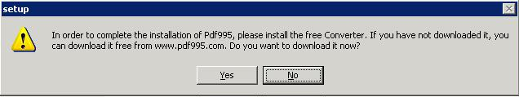

1. Run **ps2pdf995.exe,** answer **Accept** to the Pdf995 User Configuration message that will appear at the end of the install.
2. The installation will confirm success with a browser message:

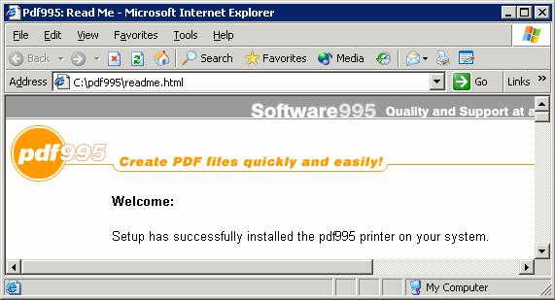

1. Run PDFKey.exe
2. Type in your name and the PDF995 key value (pedro3).

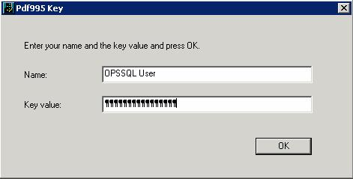

1. Click **OK** and the following message appears:

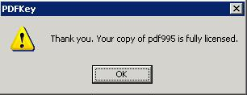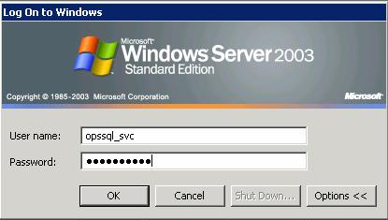

1. Log into the PC as the User that the GNR Server Service is running under. Go to **Start/Settings/Printers and Faxes**

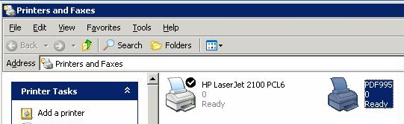

1. You should see PDF995 in the printers list

1. Right-Click on **PDF995 and select Rename**
2. Rename to OPSSQL_GNR_PDF995

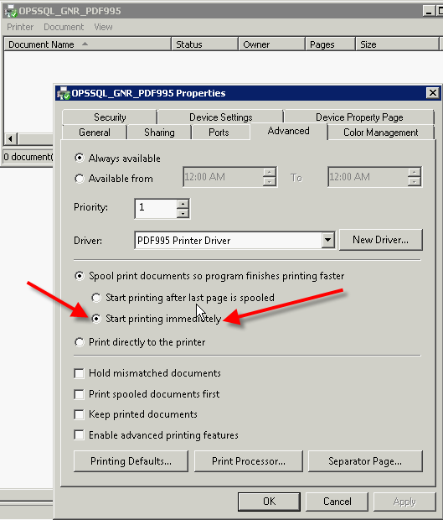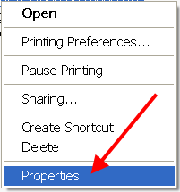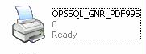

1. **Right click on OPSSQL_GNR_PDF995** and select **Properties**:
2. Set the OPSSQL_GNR_PDF995 Printer property on the advanced tab to "Start Printing immediately":   
     
     
   **NOTE**: This step addresses several issues users have had when emailing PDFs though GNR Server. You may also need to use **PDFSLEEPEXTRAMS** [Hach_WIMS_Client.ini](http://www.opssys.com/instantkb/Article.aspx?id=10447) setting (typically not required).
3. In Explorer, navigate to the Hach WIMS­­ Client folder
4. Open Hach_WIMS_Client.INI and add the following 3 settings at the end of the file:

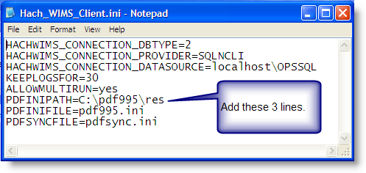

PDFINIPATH=C:\pdf995\res

PDFINIFILE=pdf995.ini

PDFSYNCFILE=pdfsync.ini

1. Save Hach_WIMS_Client.INI
2. Start the GNR Server Service.

# 1.9 Updating the Hach WIMS­­ Client

Updates are periodically released to fix bugs and add minor features to the Hach WIMS­­ system. The Hach WIMS support portal contains the update software to download. The following procedure takes you through the process.

Extract the update. Push the update into the server. Tell the server to disallow any user below a certain version. As people login, they will be forced to update.

1. Visit www.hachiim.com/support
2. If you do not have an account, create one. Log in.
3. Add your product License number.
4. Enter the Hach WIMS­­ Support area.
5. Download the latest version of the Hach WIMS­­ Client.
6. The Client update is an EXE that will extract a Setup Program. Run this EXE and extract the files.
7. You will need to run **Server Setup. Start->All Programs->Hach Company->Hach WIMS­­->Hach WIMS Server Setup (MSSQL)** and **login**.

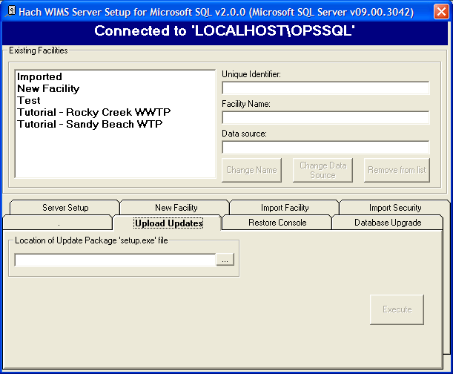

1. Go to the **Upload Updates** Tab.

1. Browse to the location where you extracted the update. Select the **Setup.exe**
2. Setup EXE will present basic information, such as the version number for the update. You will need this number for later.
3. Once the Update has been loaded, close Server Setup and Open the Hach WIMS­­ Client.
4. The update is stored in the database as a blob file that can be retrieved by any client. To force the clients to update, **Open System Setup->Admin Console**.

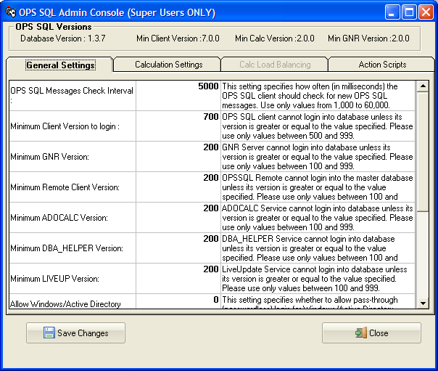

1. Change the setting called “Minimum Client Version to Login:” to the version number that was just download without any periods (7.0.0 is typed in as 700) when a client tries to connect to the server that does not meet this requirement, they will be asked to confirm an update to their client.

# 1.10 Hach WIMS­­ User Messages

Hach WIMS­­ comes with a messaging system that allows any Hach WIMS­­ user to send a message to any other Hach user.

The Hach WIMS­­ Services (ADOCALC, DBA_Helper, interfaces, etc.) will use these user messages to report about their behaviors. You can also apply a user message to ‘ping’ the Services.

To Send a Message to a user or service, go to ***Utilities*, *Send Message***:

To open your Inbox go to **Utilities-> Message Inbox.**

# 1.11 Backing up a WIMS­­ Facility

Hach WIMS­­ Facilities (Databases) can be backed up using the Hach WIMS­­ Admin Console.

1. Select System Setup, Admin Console.

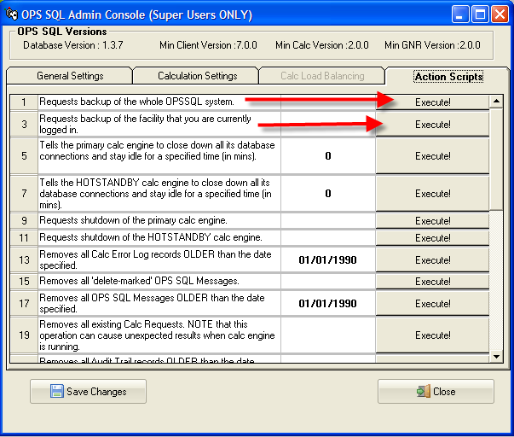

1. Click on the **Action Scripts** tab
2. Click the **Execute** button next to the backup you want to perform. “Requests backup of the whole OPSSQL System” will backup each facility and the User list, Facility List, and General Settings (i.e. the OPSROOT information). “Requests backup of the facility that you are currently logged in” will back up the current facility.
3. A request will be sent to the DBA_HELPER service.
4. When the DBA_HELPER service has completed the backup. The file created is a zip of the Microsoft SQL Server backup files (.bak).
5. The file backup file is located in the C:\HachWIMS\DbaHelper\backup folder.

# 1.12 Restoring a Hach WIMS­­ Backup

To restore a Hach WIMS­­ backup, Use Server Setup.

1. Run **Server Setup**.
2. Log in to Server Setup.
3. Select the **Restore Console** Tab.

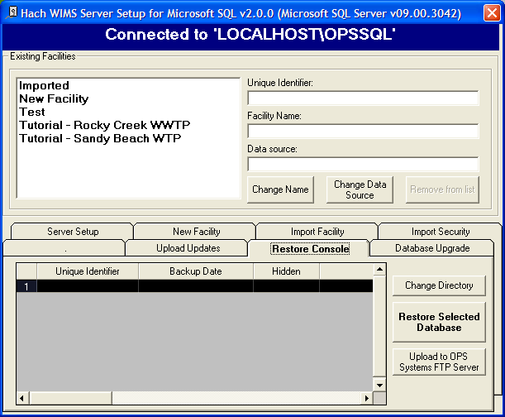

1. The Default restore Directory is the same as the default backup directory. If you have changed the default backup directory use the Change Directory button to browse to the correct directory.
2. Once you are in the correct directory with the correct backup files, you will see a list of facilities. You can use the Restore Selected Database to restore a selected database.

# Appendix A: Enabling Relaying on your Email Server for Hach WIMS­­

The Email Gateway service allows Hach WIMS­­ to send periodic emails, however Hach WIMS­­ itself is not an email server. You must have a machine with an SMTP (email) server already setup. The PC on which the Email Gateway service resides must be able to connect and use your SMTP server to actually send the email. This is called “relaying”. By default, relaying is usually disabled as a security consideration. You will need to enable relaying for the PC that is hosting the GNR service.

This guide will explain how to do this through Microsoft Exchange 2003, perform this task for later versions of Exchange is different, however the theory is the same.

**NOTE:** If you don’t feel comfortable with modifying Exchange settings, which can have far-reaching effects, please have your system administrator help you!

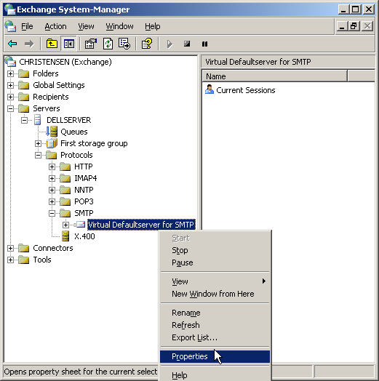

1. Open the Exchange System Manager console and navigate through the tree to Servers/Protocols/SMTP/Default SMTP Virtual Server:

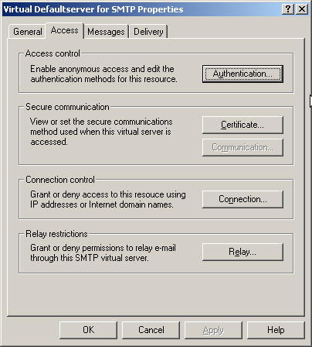

1. Click **Properties** and then click the **Access** tab:

The Access Control, Connection and Relay Restriction options need to be modified in order for email to go through. **Note:** the modification might be unnecessary if your Exchange server has already been setup properly.

1. Click the **Authentication** tab and make sure that the Anonymous Access option is enabled, as the GNR service does not authenticate as a specific user.
2. Mark the checkbox for Anonymous access and click **OK**. This should get you back to the Access tab.

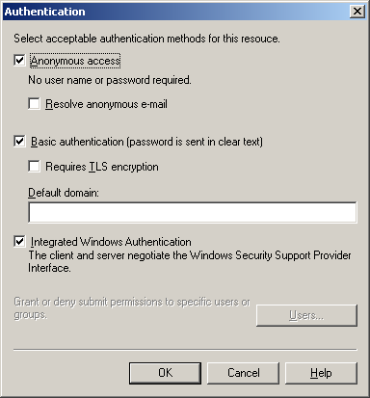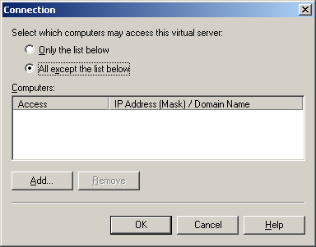

1. Click on **Connection**. The machine’s IP address that is hosting the GNR service is either listed as an allowed IP address, or is NOT listed as a blacklisted IP address.

The two radio buttons, “Only the list below” and “All except the list below” control whether the listed IP addresses/Hostnames are either white-listed or black-listed. E.g., if the radio button “Only the list below” is selected and the GNR machine is NOT listed, email sending will not work because the machine is not in the white list; if it’s present in the list, all is OK. Conversely, if the radio button “All except the list below” is checked and the GNR machine IP address/hostname is NOT listed, email will work, while if it’s in the list, it is black-listed and will get rejected.

Either make sure that it’s present in the list if the first radio button is selected or make sure it’s NOT present if the second radio button is selected. Click OK to go back to the Access tab.

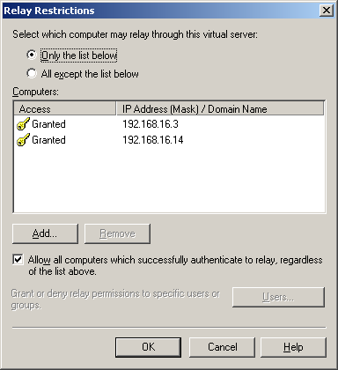

1. Click the **Relay** button to go to the Relay screen. This screen is similar to the Connection screen:

The logic is the same as under the allowed connections screen, the “Only the list below” radio button controls the white-list and you MUST make sure the GNR machine is listed, while the “All except the list below” button controls the black-listed machines and you MUST make sure the machine is NOT listed. Click **OK**.

1. Disable your anti-virus program on the SMTP (email server) machine. This is necessary because the anti-virus program interferes with the way Hach WIMS­­ sends emails.

**NOTE**: Modifying email settings can have serious security consequences. Please have your system or network administrator help you or do the actual modifications if necessary!